Hosting web application on development Machine

To install IIS please follow the link below

<https://www.howtogeek.com/112455/how-to-install-iis-8-on-windows-8/>

Step 1

Open IIS Manager

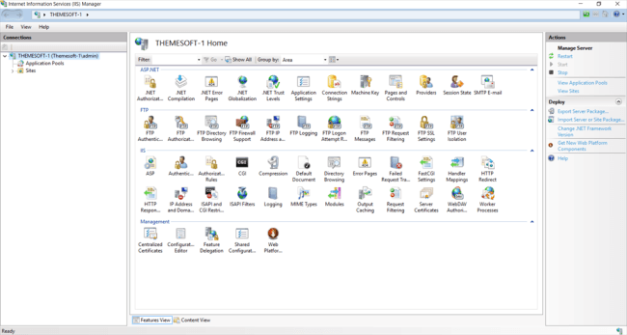

Add a new Site by right clicking Sites and select Add Website

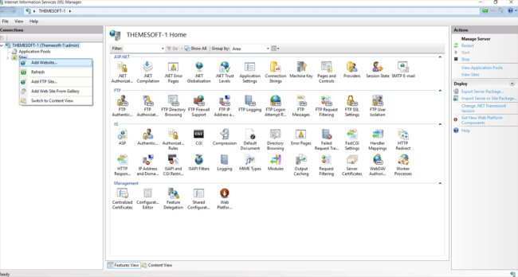

Type the site name ClassAttendance

In the Physical path add the Directory to the website

Example: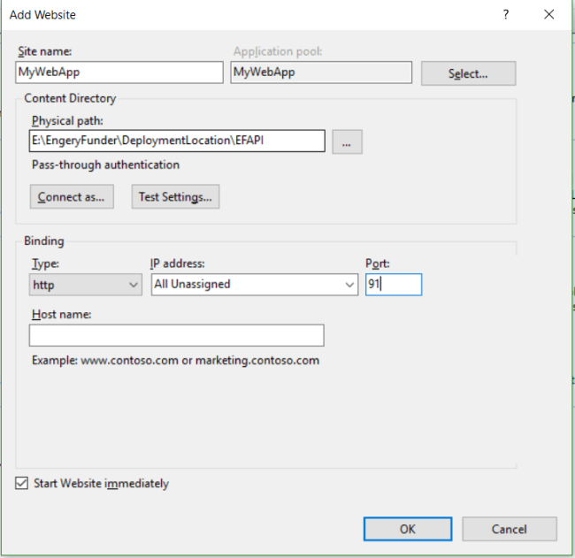

To Browse the application open the Sites Folder and navigate to the ClassAttendance website

Click start under manage website

To browse the site

Click on the link under the Browse Website Menu Section